Benha University Shoubra Faculty of Engineering Mechanical Eng. Dept. (Power) 4thyear (2016-2017)
Internal Combustion Engines Sheet No. (1)
=================================================================
1-What is the distance of the piston from top dead center (TDC) to bottom dead center (BDC) called?
2- What is the ratio called that compares the volume of the air space above the piston at TDC and BDC.
3- The crankshaft for 4-stroke engine turns _____ as the camshaft.
4- What causes ignition to occur in a diesel engine.
5- Describe the major functions of the following reciprocating engine components: piston, connecting rod, crankshaft, camshaft, valves.
6- Describe the four strokes in internal combustion engine?
7- List five differences between SI engines and CI engines.
8- How many times in 1 second will a valve open in an engine running at 6000 rpm?
9- Write down the name of the each part in the following schematic.
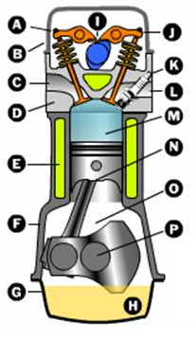

Sheet No. (1) – (ICE)
=================================================================
1-What is the distance of the piston from top dead center (TDC) to bottom dead center (BDC) called?
It is called stroke.

2- What is the ratio called that compares the volume of the air space above the piston at TDC and BDC.
It is called compression ratio.

3- The crankshaft for 4-stroke engine turns _____ as the camshaft.
The crankshaft for 4-stroke engine turns _twice_ as the camshaft

4- What causes ignition to occur in a diesel engine.
In diesel engine the ignition occurs due to the mixture of air and fuel reach to the self ignition temperature of fuel by increasing the pressure inside the engine cylinder.

5- Describe the major functions of the following reciprocating engine components:
Piston:- is a cylindrical piece of metal that moves up and down inside the cylinder.

Connecting rod:- It connects the piston to the crankshaft. It can rotate at both ends so that its angle can change as the piston moves and the crankshaft rotates.

Crankshaft:- The crankshaft turns the pistons up and down motion into circular.

Camshaft:- This usually consists of the Intake Camshaft and Exhaust Camshaft which are used to open and close the intake valves and the exhaust valves respectively, in sequence with the four-stroke cycle of the pistons.

Valves:- The intake and exhaust valves open at the proper time to let in air and fuel and to let out exhaust respectively. Both valves are closed during compression and combustion so that the combustion chamber is sealed

6- Describe the four strokes in internal combustion engine?
The four strokes are as below:
1) Intake stroke or the Induction stroke
Here, the piston descends from the top of the cylinder, reducing the pressure inside the cylinder. The intake valve opens. A mixture of fuel and air is forced (by atmospheric or greater pressure) into the cylinder through the intake (inlet) port. Only the tiniest drop of gasoline needs to be mixed into the air. The intake (inlet) valve (or valves) will then close. This is informally known as ‘suck’.

2) Compression stroke
The fuel-air mixture is compressed adiabatically (no exchange of heat energy with external environment) in the cylinder when the piston moves back up. This is to enhance the ignition of the mixture in the power stroke and is informally known as ‘squeeze’ or ‘squash’.

3) Combustion stroke or Power Stroke
At the end of compression, the spark plug emits a high-voltage electrical spark to trigger ignition of mixture which combusts and explodes, creating gases at high temperature (can be as high as over 1000oC and pressure, thus pushing the piston downwards. This is an adiabatic expansion and is informally known as ‘bang’.

4) Exhaust stroke
Lastly, once the piston hits the bottom of its stroke, the exhaust valve(s) open(s) and the piston pushes the products of combustion from the cylinder to go out the tailpipe. This is informally known as ‘blow’.

After the four strokes, any heat that is not translated into work is normally considered a waste product and is removed from the engine either by an air or liquid cooling system.
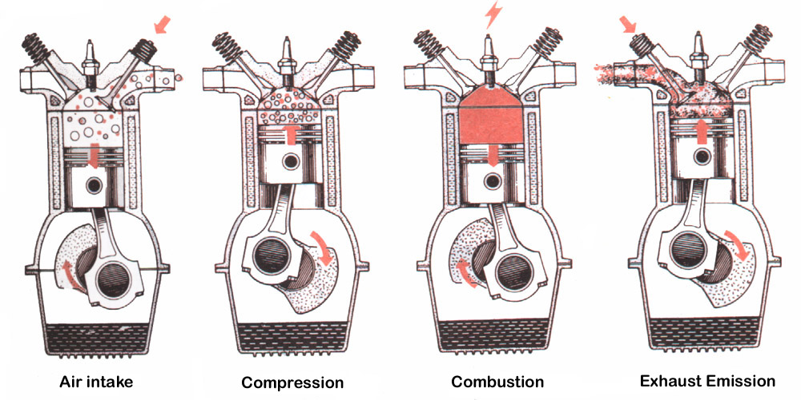

7- List five differences between SI engines and CI engines.

 | Spark Ignition Engine | Compression Ignition Engine
Basic Cycle | Operated on Otto cycle. | Operated on Diesel cycle.
Fuel Used | Gasoline fuel.  Because it have higher self ignition temperate. | Diesel fuel.  Because it have lower self ignition temperate.
Method of Introducing of Fuel | Homogeneous gases mixture of air and fuel is sucked inside the engine during suction stroke  By carburetor or injector | Fuel is injected inside the engine cylinder at high pressure near the end of compression stroke  By fuel pump and injector
Ignition | Fuel is ignited by use of electric ignition system with spark plug required to initiate the combustion.  The combustion takes place at constant volume. | Fuel is ignited automatically due to high temperature at end of compression stroke.  The combustion takes place at constant pressure.
Compression Ratio | Operating at range of 6-11 | Operating at range of 14-22
Speed | Higher, because of lighter engine. | Lower, because of heavier engine.
Efficiency | Lower  Because of lower compression ratio. | Higher  Because of higher compression ratio.
Weight | Lighter than Diesel.  Because it has low compression ratio and lower max pressure so that the cylinder thickness be small and volume be small. | Heavier than Petrol.  Because it has high compression ratio and higher max pressure so that the cylinder thickness be high and volume be heavy.
Air/Fuel ratio | Be around 15:1 | Change according to the load on the engine from 20:1 to 200:1.

8- How many times in 1 second will a valve open in an engine running at 6000 rpm?
In one second the valve opens 50 times.

9- Write down the name of the each part in the following schematic.

